

**Lab Manual- Create EC2 Instance for Windows VM on AWS Platform**

**TABLE OF CONTENTS:**

|  |  |  |
| --- | --- | --- |
| **1** | **Objective** | **2** |
| **2** | **EC2 Instance Types** | **2** |
| **3** | **Pre Requisites** | **2** |
| **4** | **Creating Windows EC2 Instance** | **3** |

1. **OBJECTIVE**

An instance is a virtual server in the AWS Cloud. With Amazon EC2, you can set up and configure the operating system and applications that run on your instance.

Amazon EC2 provides a wide selection of instance types optimized to fit different use cases. Instance types comprise varying combinations of CPU, memory, storage, and networking capacity and give you the flexibility to choose the appropriate mix of resources for your applications.

EC2 Instance can even be launched with help of AWS CLI

**Note:** *When you sign up for AWS, you can get started with Amazon EC2 using the* [*AWS Free Tier*](https://aws.amazon.com/free/)*. If you created your AWS account less than 12 months ago,and have not already exceeded the free tier benefits for Amazon EC2, it will not cost you anything to complete this tutorial, because we help you select options that are within the free tier benefits. Otherwise, you'll incur the standard Amazon EC2 usage fees from the time that you launch the instance until you terminate the instance (which is the final task of this tutorial), even if it remains idle.*

1. **EC2 Instance types**

It is important to select the right instance size and type for the working of our virtual machine perfectly. So, these are the types that are available within AWS.

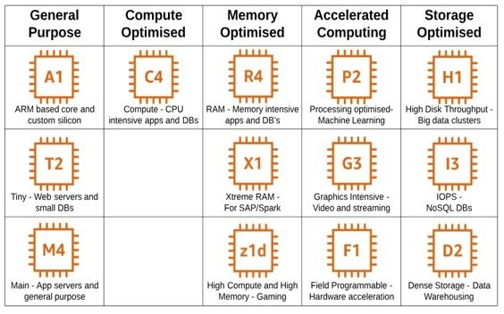

1. **PRE-REQUISISTE**

* **Accounts in AWS A local Computer with 4 CPU, 16 GB RAM, 200 GB disk space**

1. **Creating Windows EC2 instance and connect with RDP**

**Step 1:** Login to AWS management Console and Type EC2 in service search box and click on it.

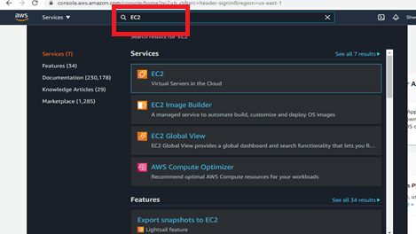

**Step 2:** In EC2 dashboard click **instances** from left side menu and click **Launch Instance**

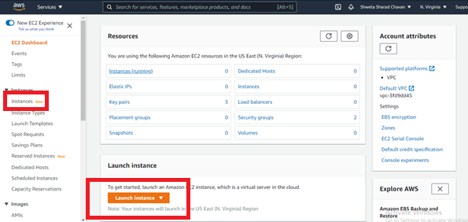

**Step 3:** First Step is to choose an Amazon Machine Image so select **Windows Server 2016 Base** as we are creating a Windows VM.  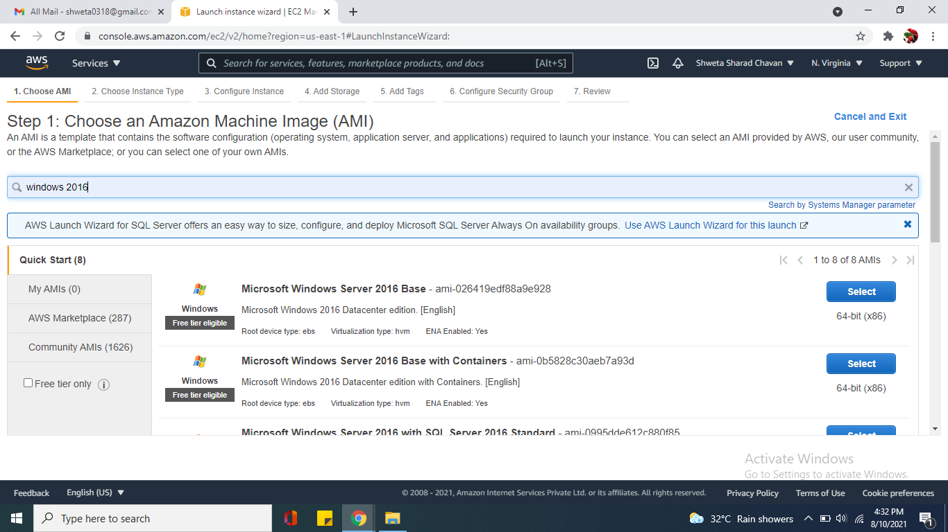**Step 4:**Choose Instance Type as we select a free tier eligible **t2 micro** instance provides **1vCP**U and **1Gb** Memory.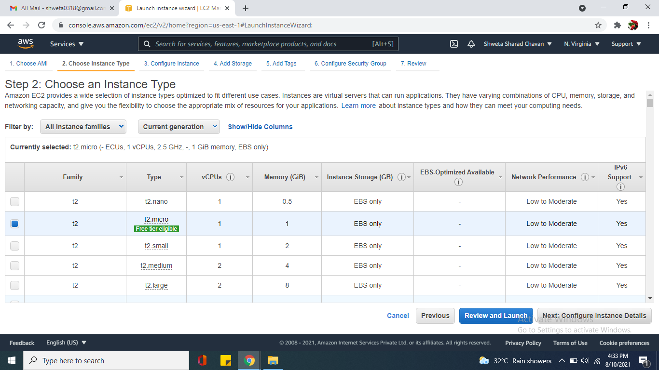**Step 5:** Keep the **default option** in Configure Instance. Notice the VPC and Click Next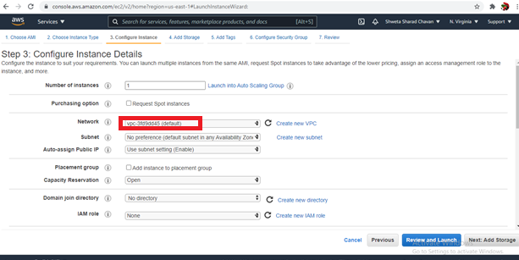

**Step 6:** in add storage details as default as we are creating it for training purpose and move to add Tags. 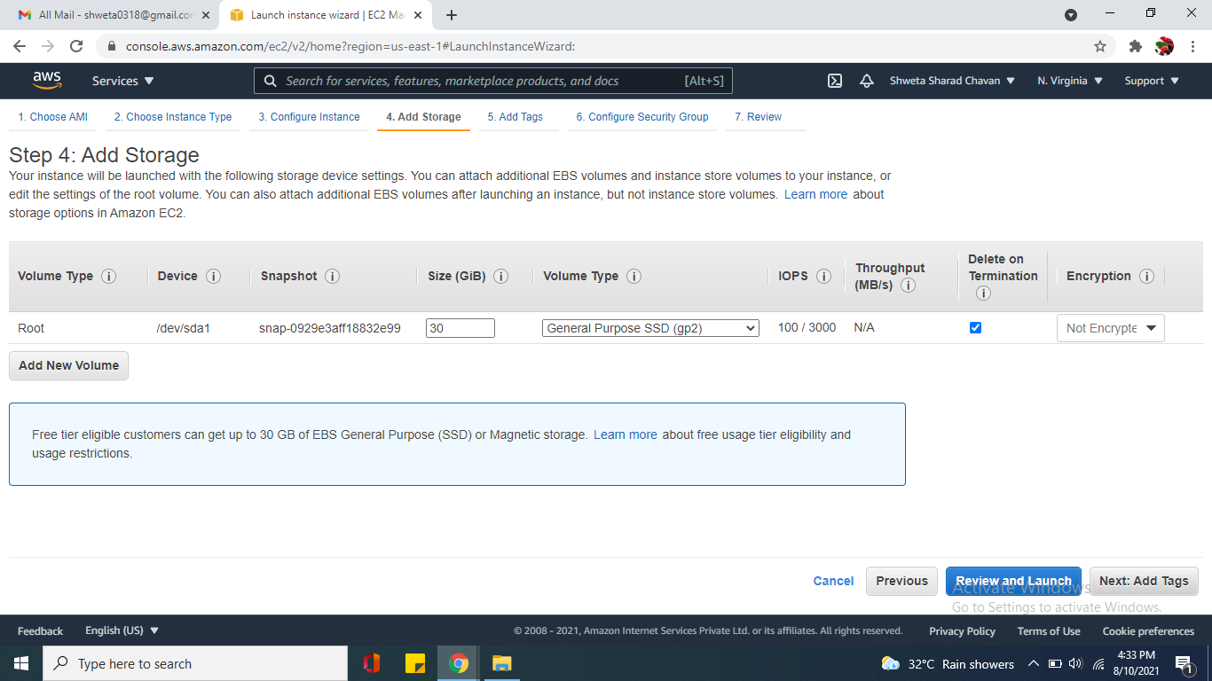

**Step 6:** Leave the Tag option Default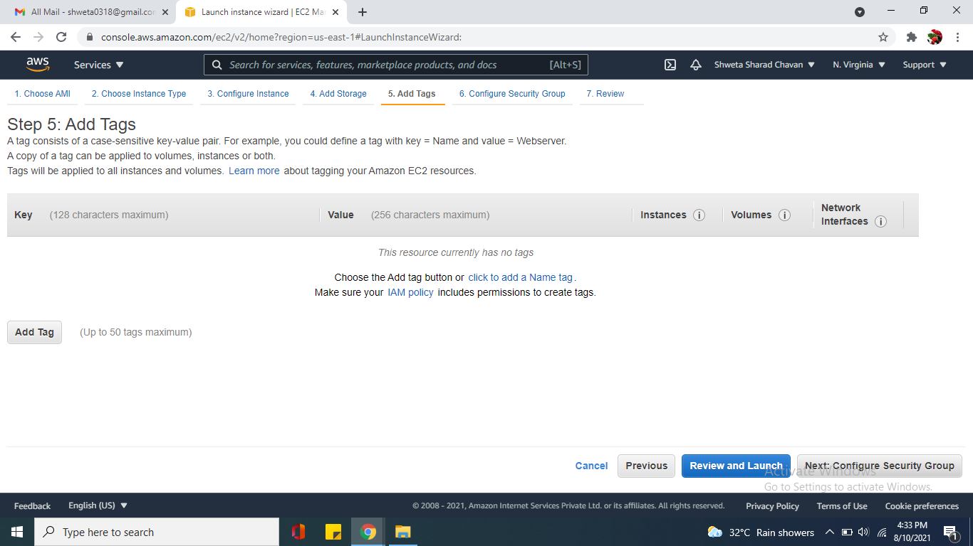 **Step 8:** Next Configure **Security group** by creating a security group letting a default name and description and adding rules as RDP and **All traffic** to be allowed from anywhere source. 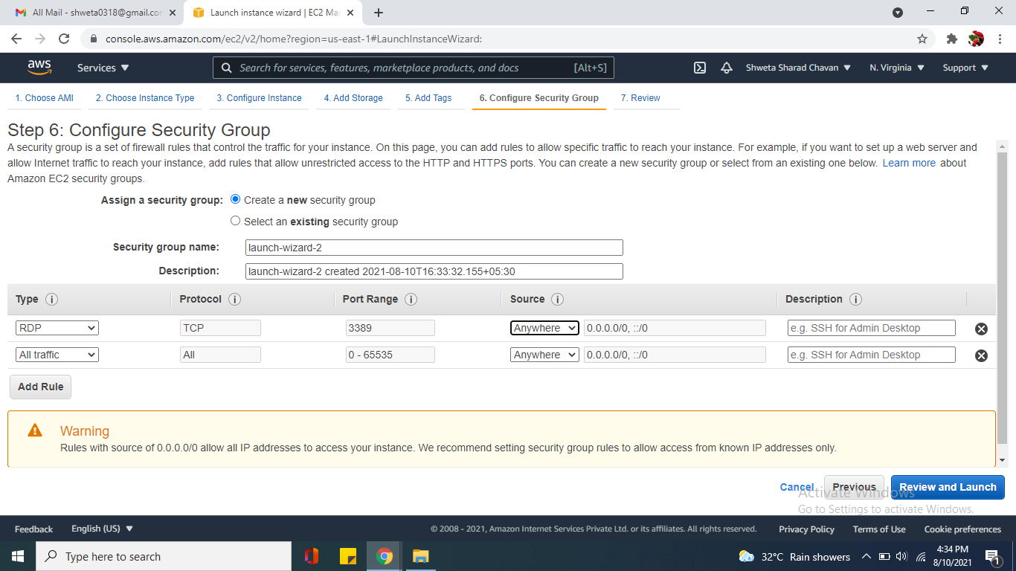**Step 9:** Lastly Review the instance and click launch . 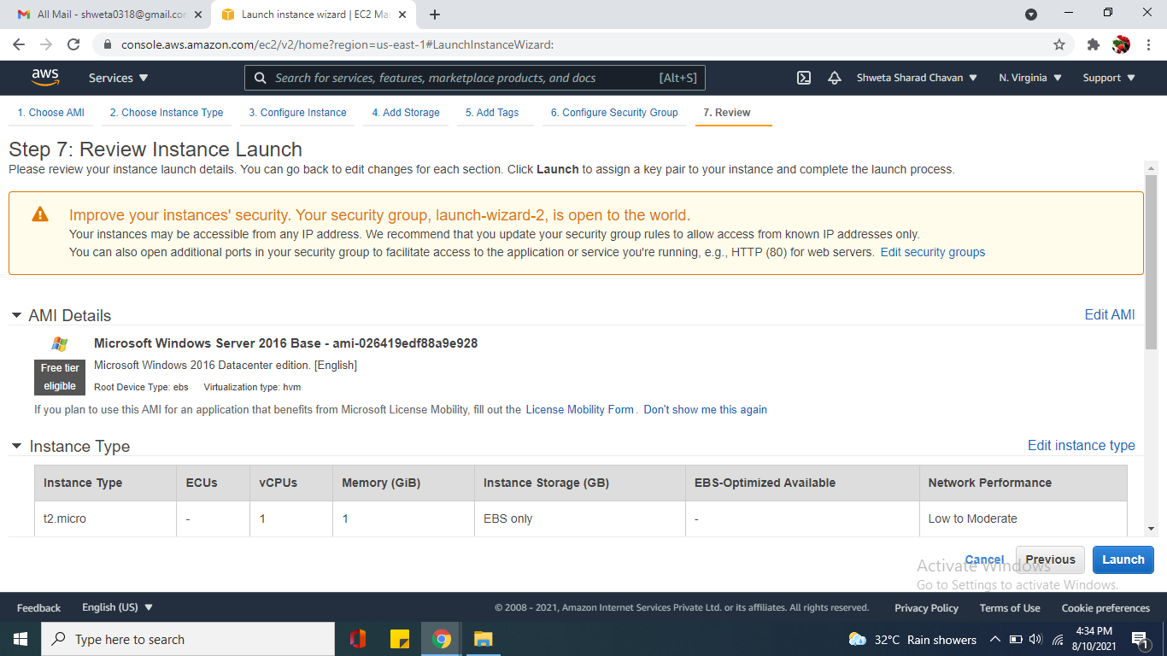**Step 10:** As Password required to login to instance, for that create a key to obtain it and name the **keypair** as key pair.Also, **download the key pair** , losing this .pem file will not let you obtain your password.. 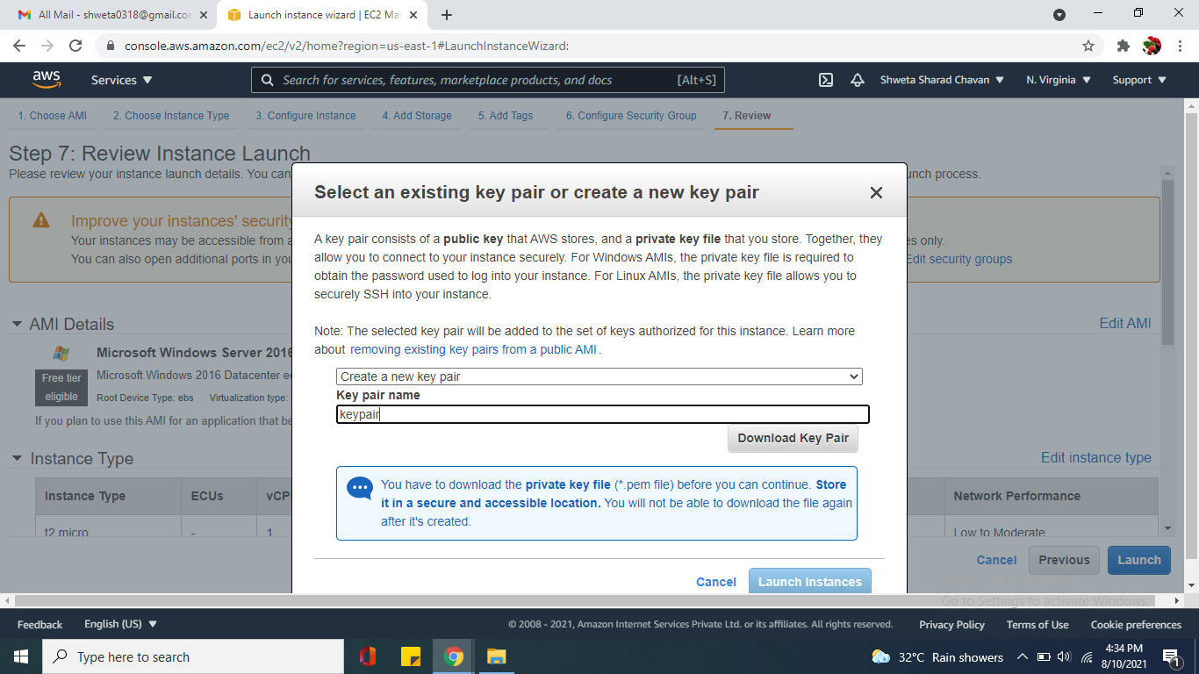**Step 11:** Wait and observe the instance state from pending to running and status checked from initializing to 2/2 checks passed then your instance is launched and ready to connect.. 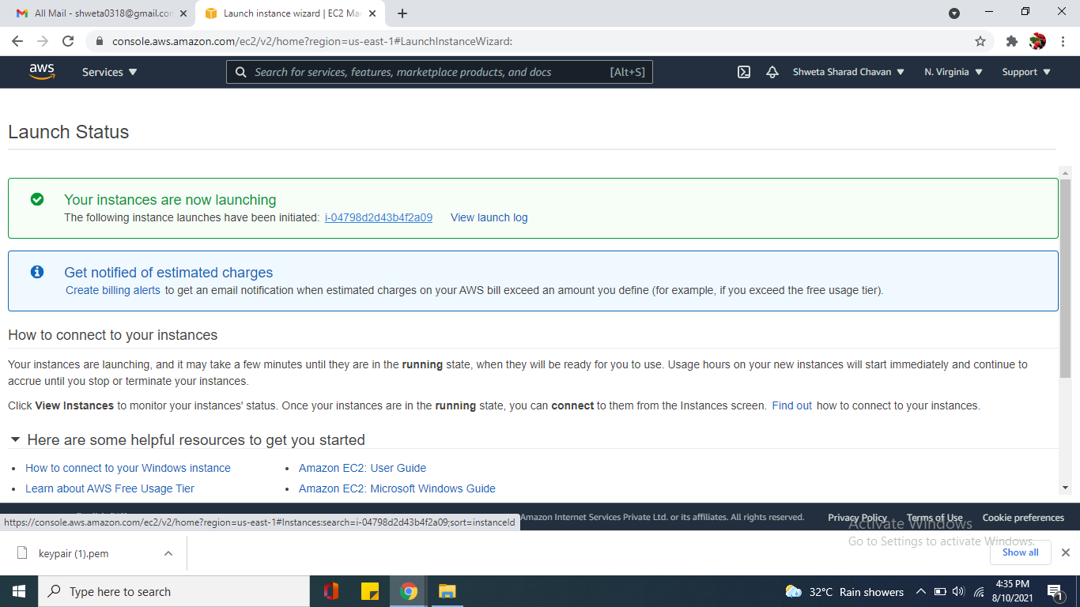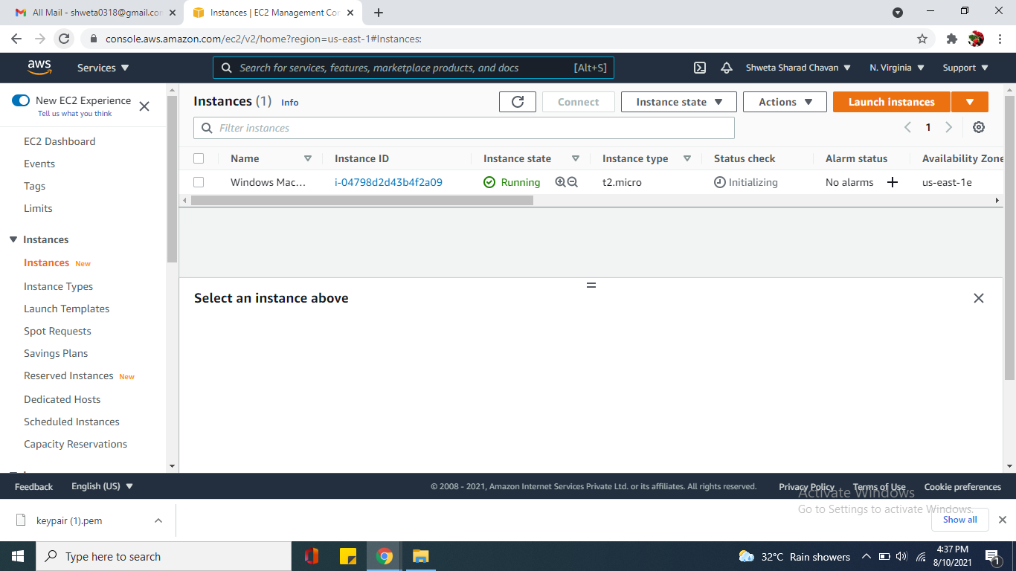

**Step 12:** Click Connect, Login via RDP

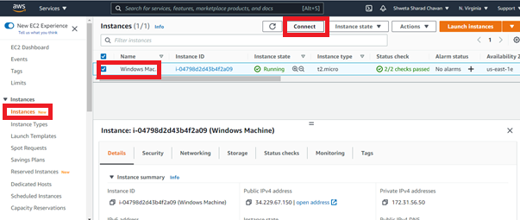b

**Step 12:** Select RDP Client and browse your keypair.pem file upload it 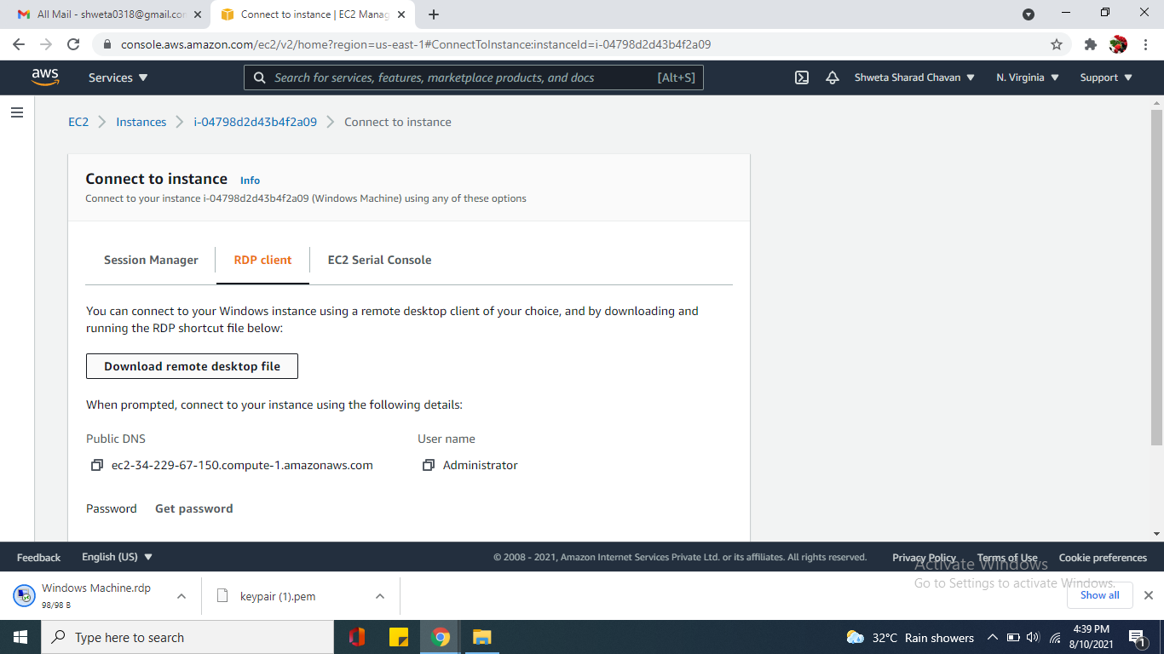

**Step 13:** Decrypt The Password and the password obtained is to be copied..

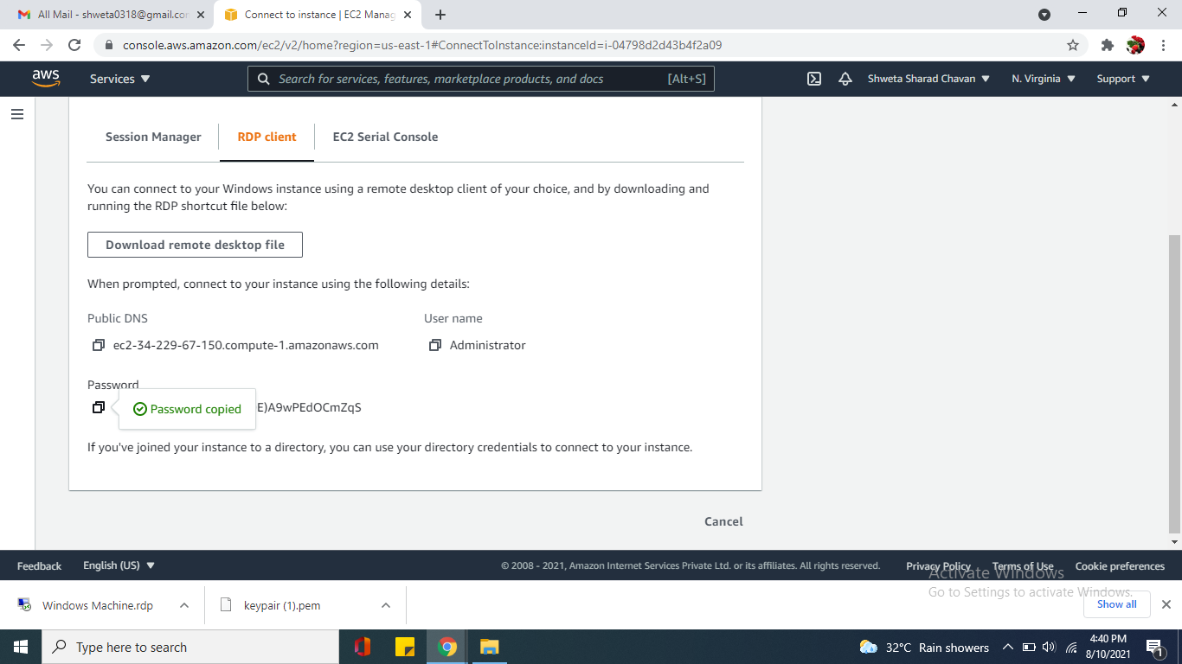

**Step 14:** Download the RDP File.

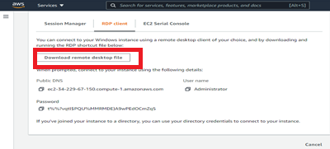

**Step 15:** Open the RDP downloaded file connect and enter the password and accept the certificate, this will connect to your windows instance. 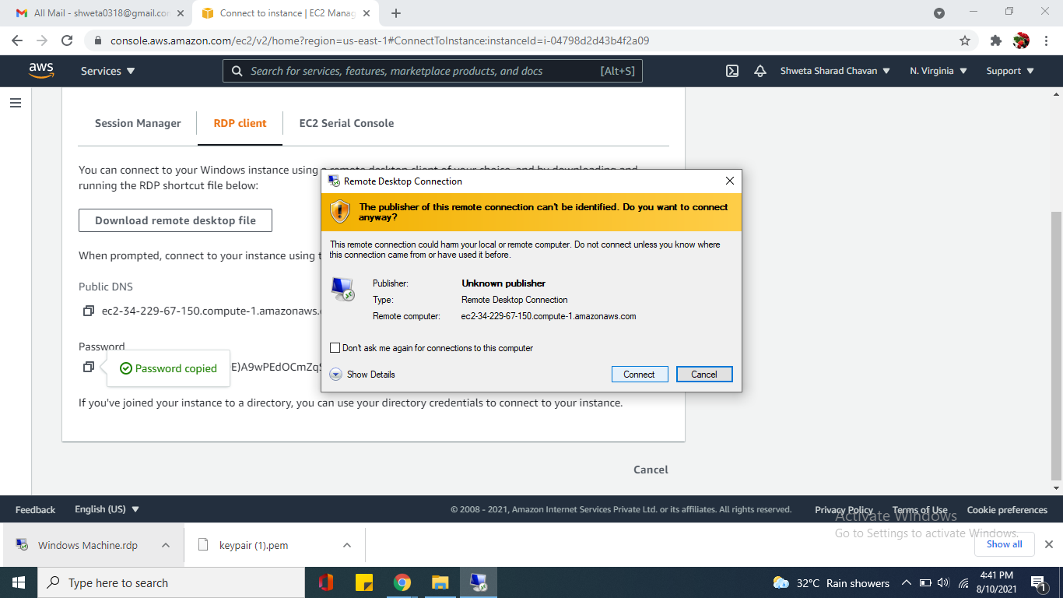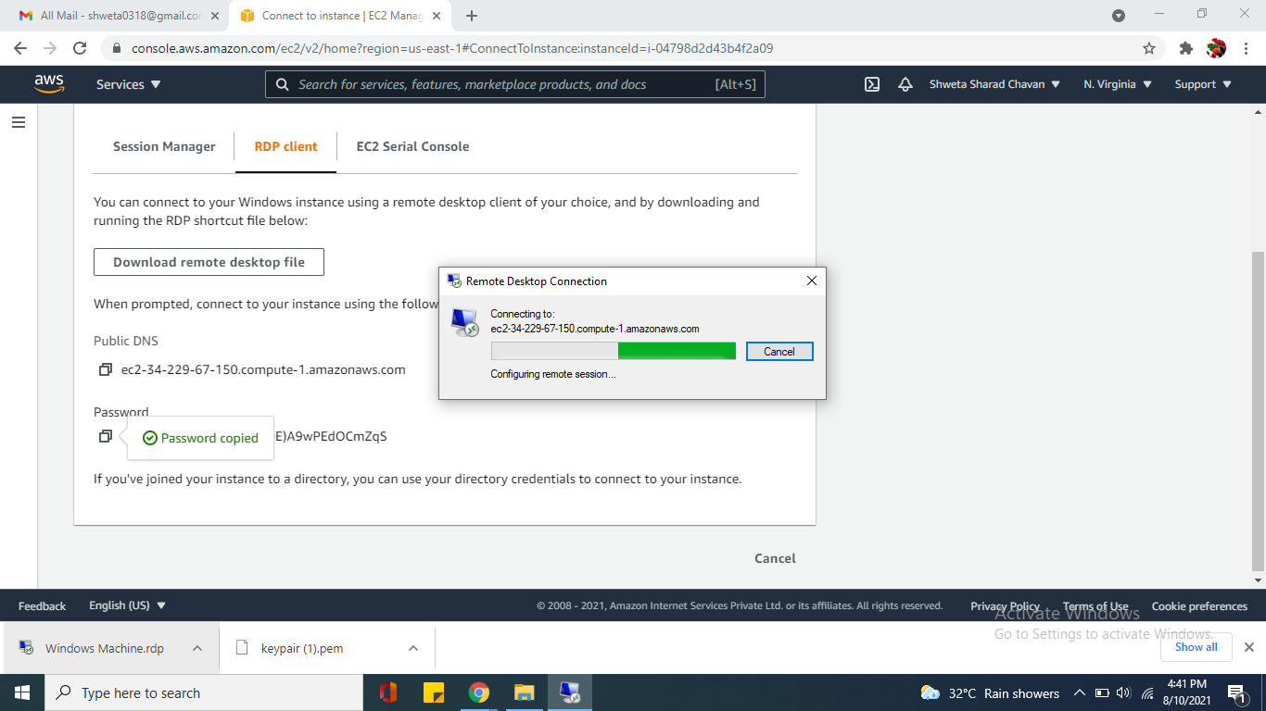   
**Step 16:** Paste Your Password

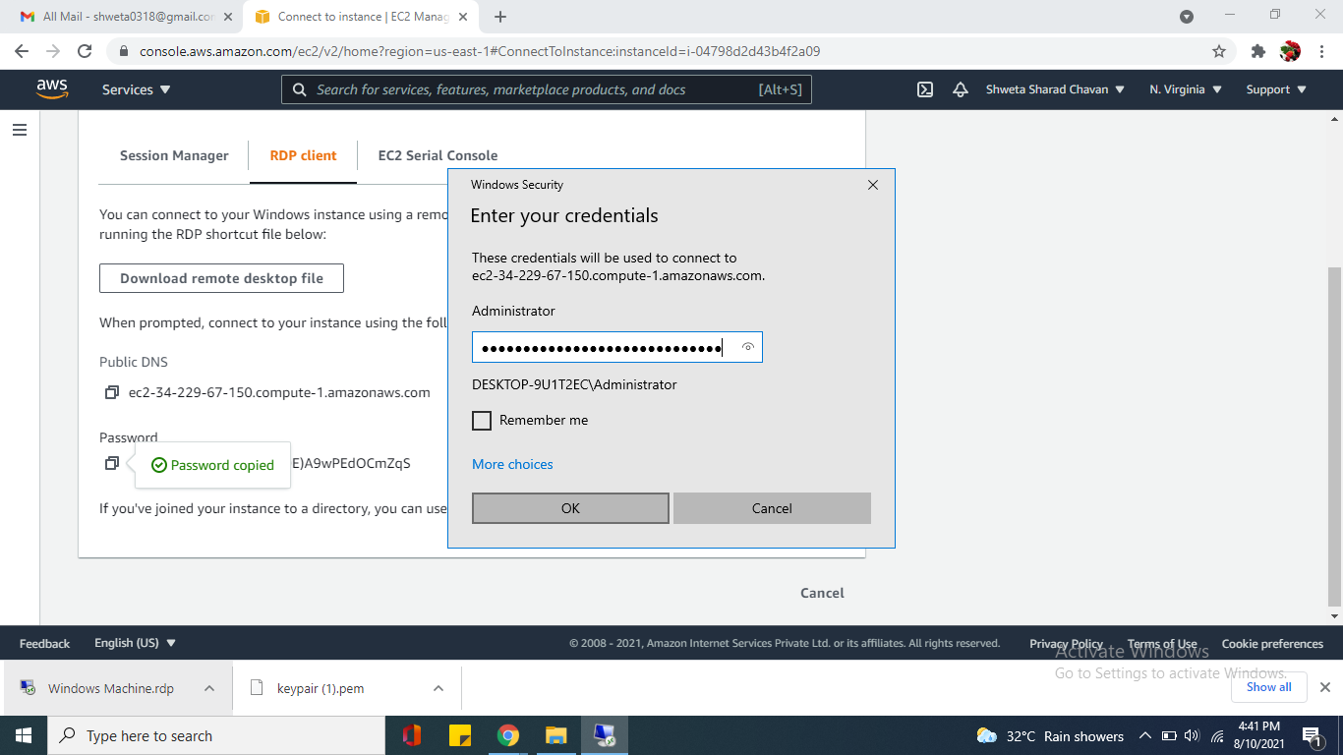

**Step 17:** Click Yes

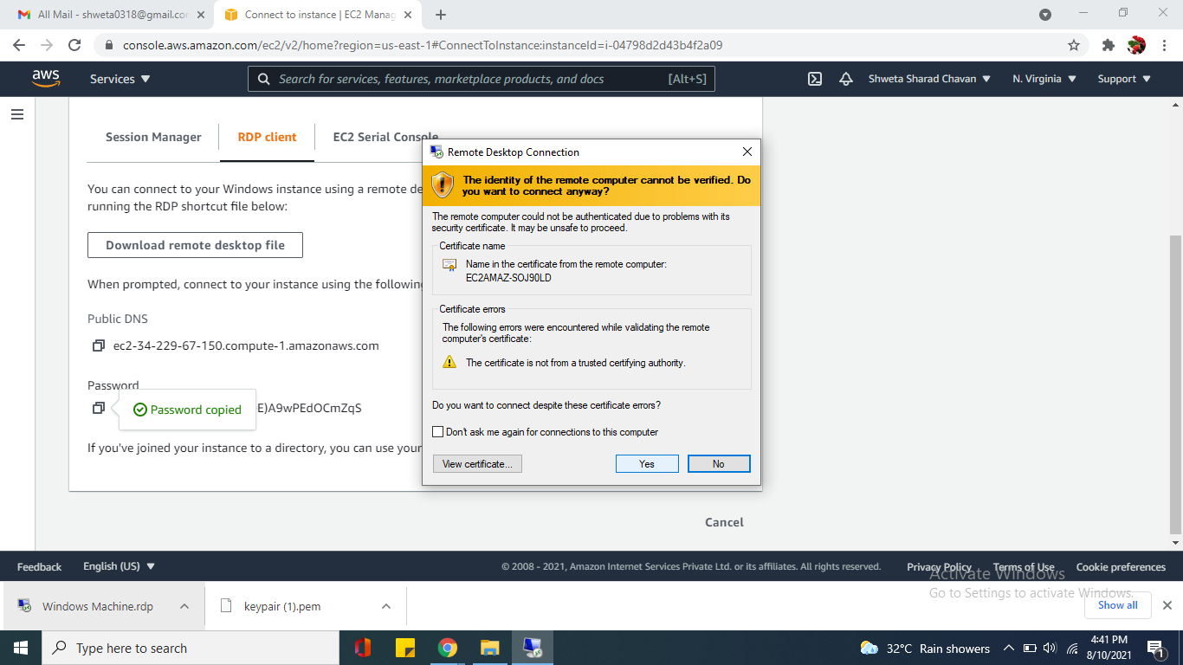**Step 18:** No more into physical machine, entered an Virtual environment with a ready to use Windows Server 2016 VM on right side of vm all details available. 